M 35 Wankel engined coupé
Project F would have been equipped with a Wankel rotary engine and as part of the test régime for that engine, a couple of hundred hydropneumatically suspended Ami coupes were built for testing by a selected number of high mileage motorists. The M 35 was also a test bed for the hydraulics employed in F and later in Project G. Unlike many prototypes, the M 35 was available for all and sundry to view.  The body was constructed by Heuliez and apart from the front wings, shared no components with the Ami 8. | 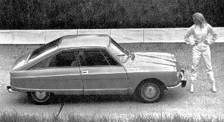
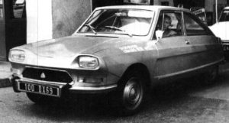 | 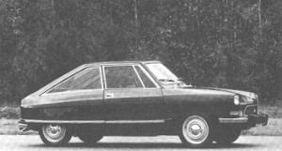
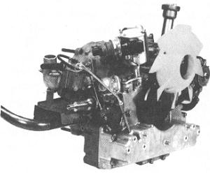 | 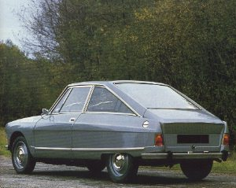
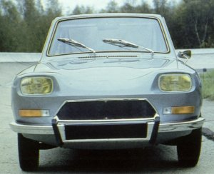 | 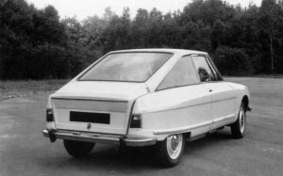
 | It was intended to build 500 M 35s but only 267 were ever constructed. What a pity that the remaining 233 bodyshells were not used as the basis for a limited run of Ami Super coupés.

